Dot in the circle

**Problem Description:**

The task is simple, you are given a circle with three different regions. Where three radii divide the circle into three congruent regions. (You are more understood given picture)

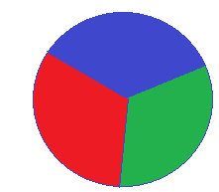

And a dot hit this circle, where probability (hit the red region) is area of red region divide area of circle, green and blue region same as above.

Now find the expected number of dot throw in a circle for getting N consecutive any color of this circle.

Input:

The first line contain a single integer **T (1<=T<=100)**, which denoted the number of test case. Each of the following **T** lines contain two integers **R** and **N (1<=R<=10, 2<=N<=10)** –Radius of circle and Number of time any color. Print three digits after the decimal point.

Output:

For each test case print case number and expected number of dot throw in the circle.

Sample Input / Output:

|  |  |
| --- | --- |
| input | Output |
| 3  2 3  5 2 | Case 1 : 39.000  Case 2 : 12.000 |